How to Create a College Board Student Account

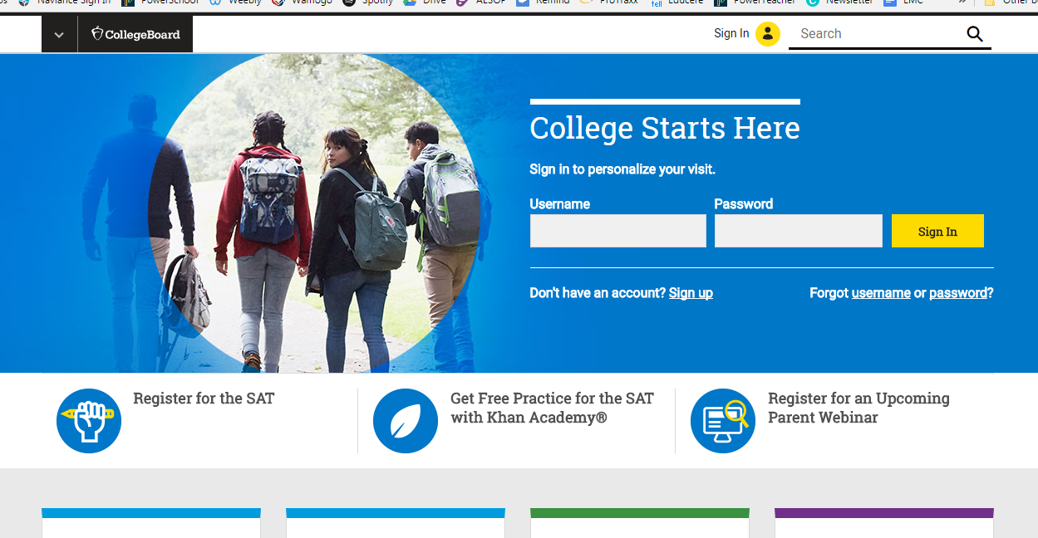
Step 1.) Go to www.CollegeBoard.org and click on “Sign Up”

Step 2.) Indicate you are a student by clicking on the “Student” link
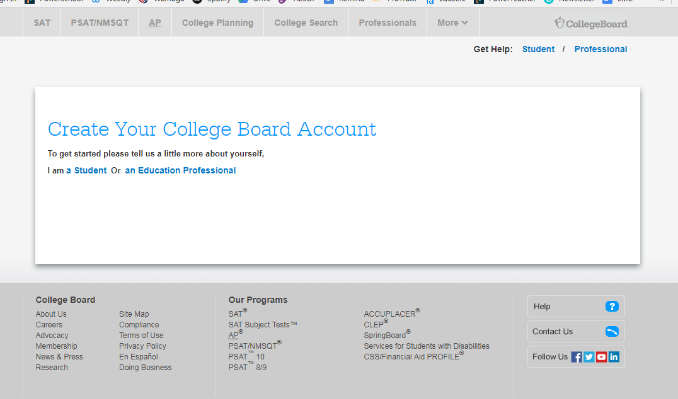

Step 3.) Fill in the required General Student Information

- First Name - Email Address (use your rsd6.org email)
- Last Name - Graduation Date (Grade 9: June 2021; Grade 10: June 2020)
- Gender - Zip Code
- Date of Birth - School Name (Wamogo Regional High School)

Step 4.) Create your Username and Password

  - Your username should be your last name, the first two initials of your first name, and your graduation year (Example: brousseauje2020)
  - Your password should be your birthdate (month written out with a capital letter, and the number day) (Example: March12)

Step 5.)
- Complete the Parent Information, if possible.
- Agree to the Terms and Conditions and click “Next”

Step 6.) Confirm your information by clicking on the boxes by your name, gender, and DOB; then click “Confirm.”

