Finding the Senior Future Plans Survey
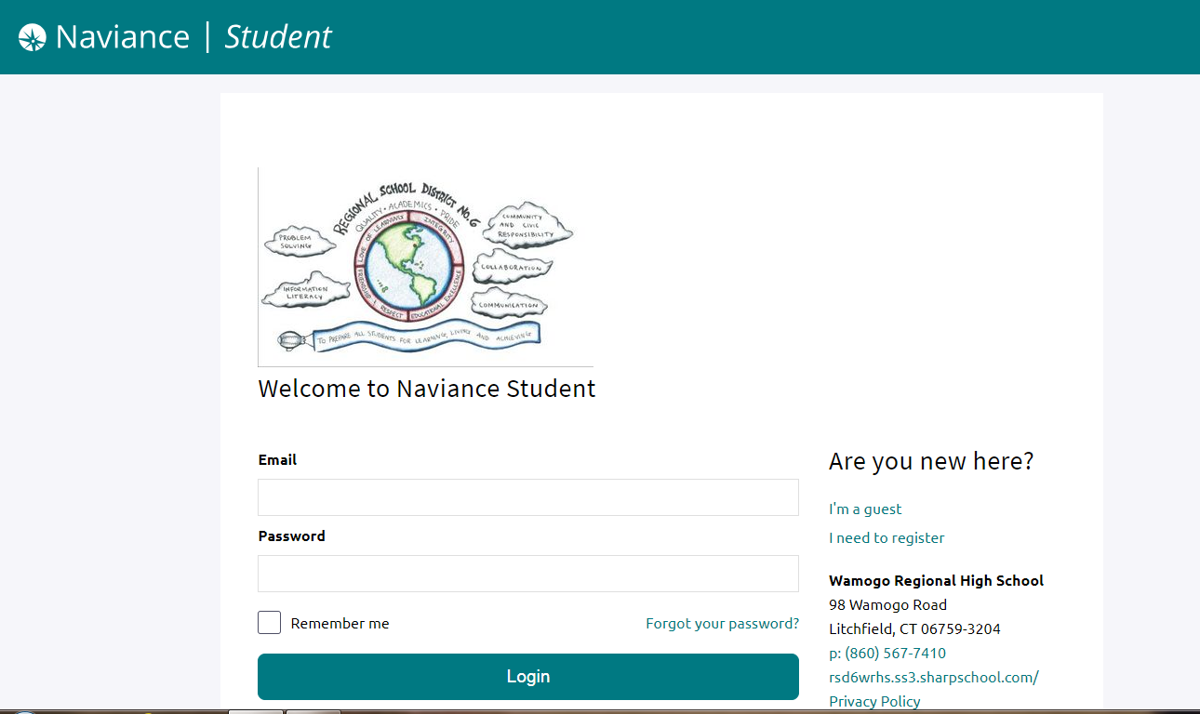

1. Log in to Naviance Student at ttps://student.naviance.com/wamogo

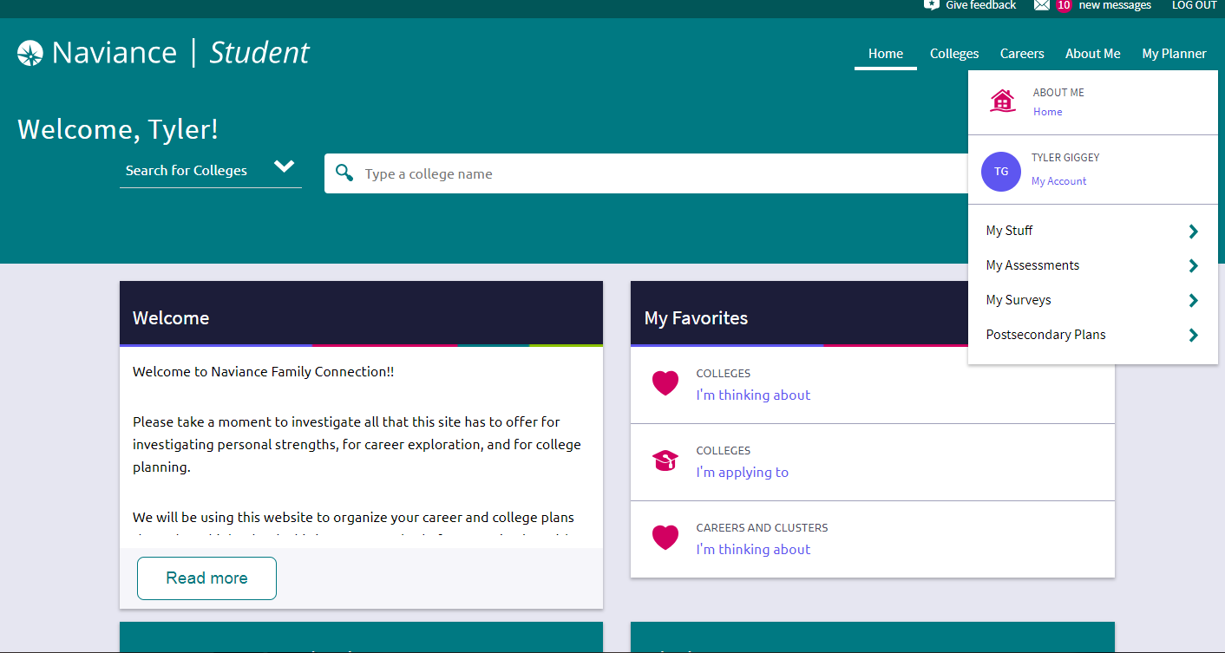

2. Click on the “About Me” tab at the top of the page
- Then click on “My Surveys”
- Then click on “Surveys Not Started”

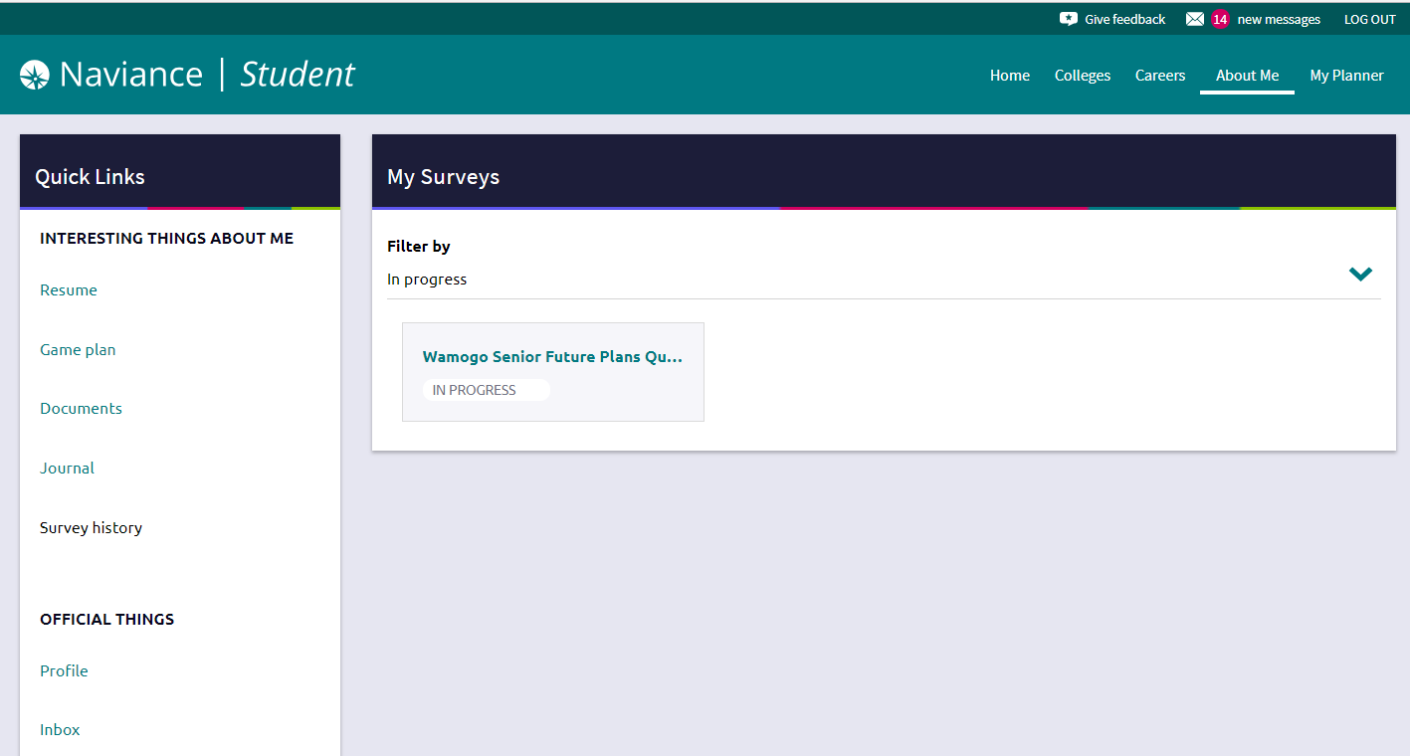
3. Click on “Wamogo Senior Future Plans Questionnaire”

* Fill in the survey and click on “Save and Finish” at the bottom of the page when completed.

** The survey can be saved for completion at a later date by clicking on “Save and Come Back” at the bottom of the page

