How to Request Letters of Recommendation
In Naviance Student
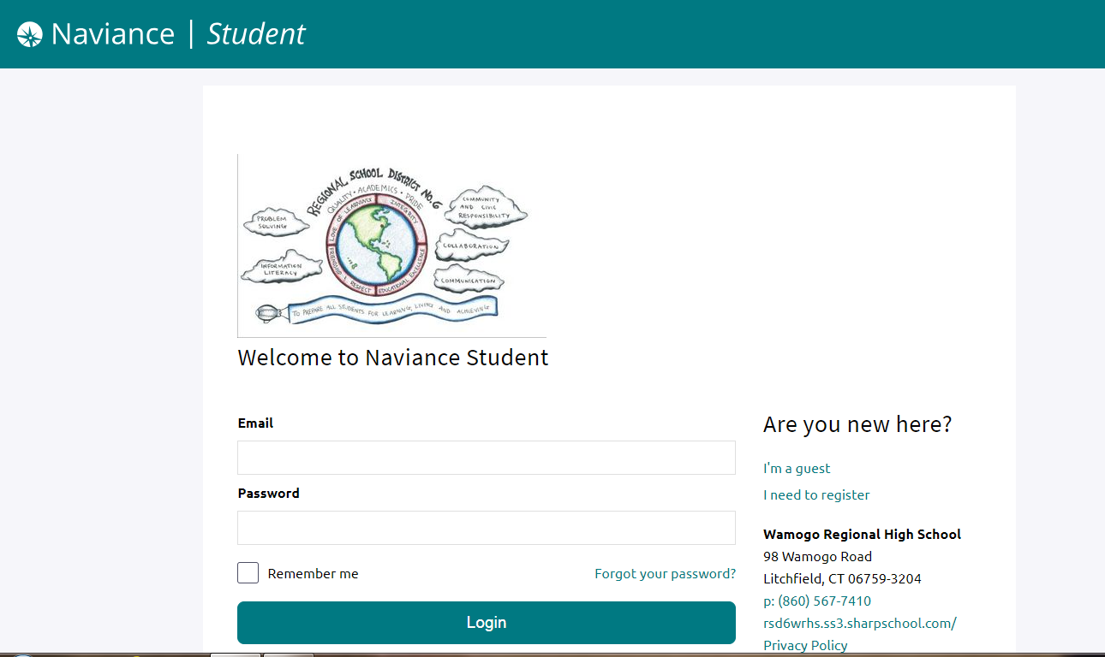

1. Log in to Naviance at https://student.naviance.com/wamogo

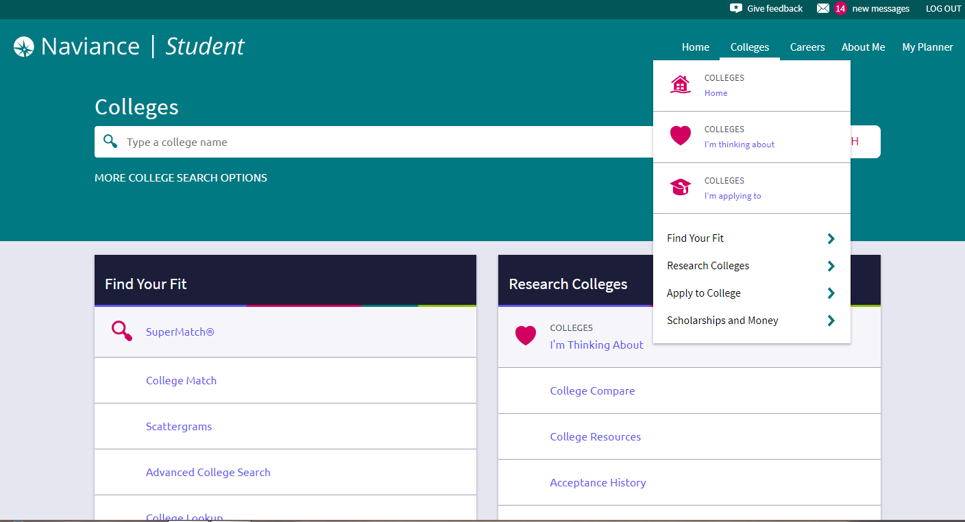
2. Click on the “Colleges” tab at the top of the page - then click on “Colleges Home”

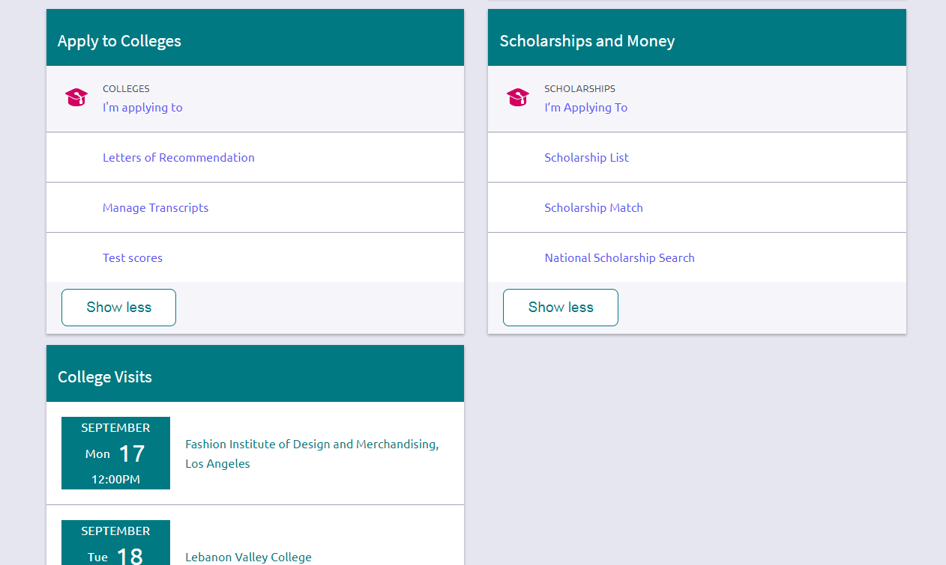
3. Scroll down and click on “Letters of Recommendation” under the “Apply to Colleges” section of the page

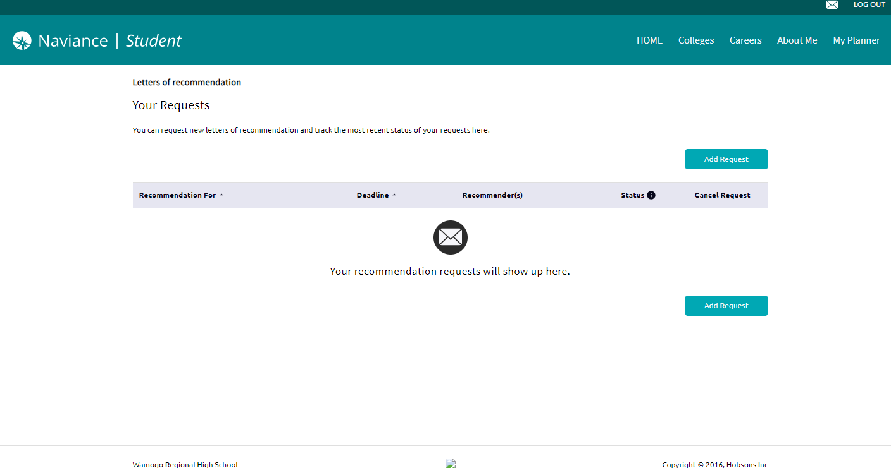
4. Click “Add Request” and select the teacher you would like a letter from. Repeat for second teacher.

