How to Subscribe to Wamogo’s E-Blasts

1. Go to the Wamogo High School website (rsd6wrhs.ss3.sharpschool.com), hover above the “For Parents” tab at the top of the screen, then on “E-News” in the drop down menu.
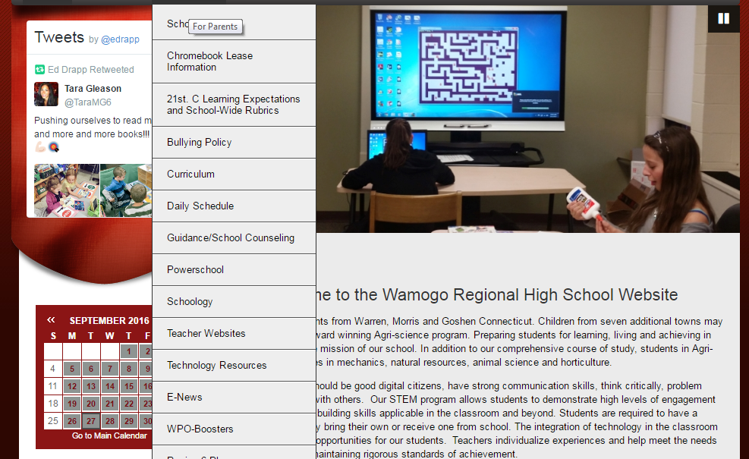
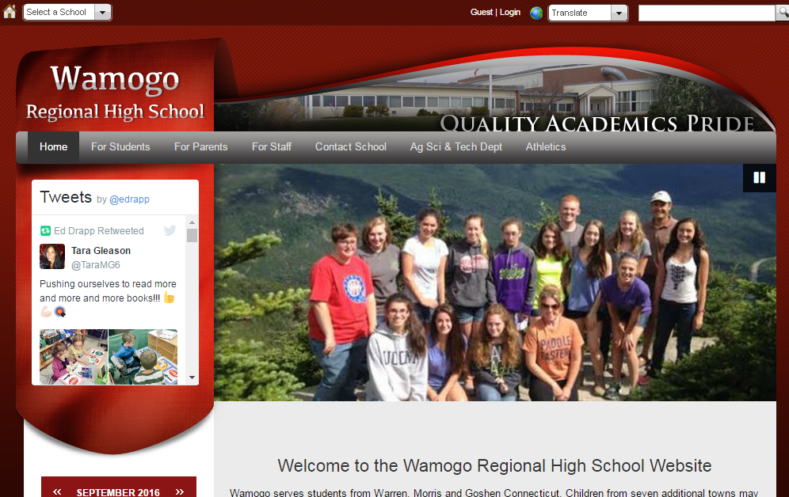
2. On this page, you will be prompted to enter the email address where you would like to receive Wamogo’s E-Blast


